Unit 2
Cloud Computing Architecture ,Virtualization and Its Role in Cloud Computing , Cloud
Service Models: Infrastructure as a Service (IaaS) ,Platform as a Service (PaaS) , Software as
a Service (SaaS) ,Cloud Deployment Models: Public Cloud ,Private Cloud ,Hybrid
Cloud ,Community Cloud . Cloud Security Models ,Identity and Access Management
(IAM) ,Threats in Cloud Security and Mitigation Strategies.

Cloud Computing Architecture:
It is possible to organize all the concrete realizations of cloud computing into a layered view covering the entire stack as per below figure, from hardware appliances to software systems. Cloud resources are harnessed to offer the “computing horsepower” required for providing services. Often, this layer is implemented using a data center in which hundreds and thousands of nodes are stacked together. Cloud infrastructure can be heterogeneous in nature because a variety of resources, such as clusters and even networked PCs, can be used to build it. Moreover, database systems and other storage services can also be part of the infrastructure.
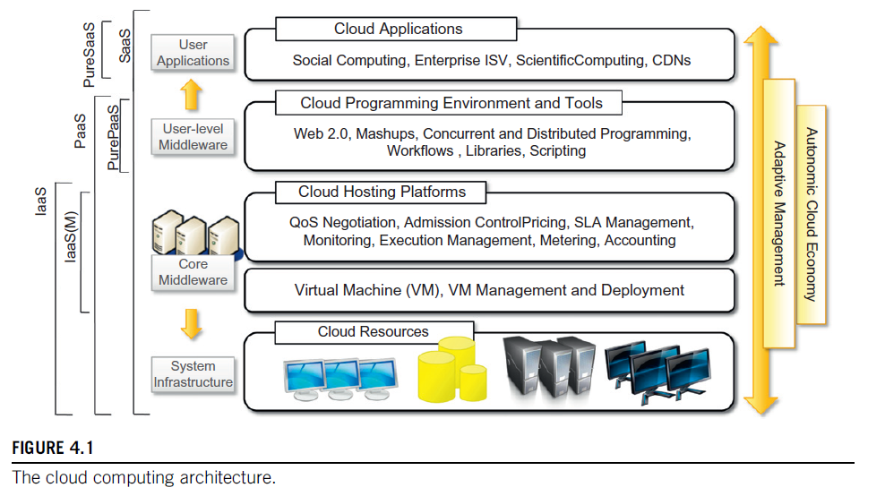
The physical infrastructure is managed by the core middleware, the objectives of which are to provide an appropriate runtime environment for applications and to best utilize resources. At the bottom of the stack, virtualization technologies are used to guarantee runtime environment customization, application isolation, sandboxing, and quality of service. Hardware virtualization is most commonly used at this level. Hypervisors manage the pool of resources and expose the distributed infrastructure as a collection of virtual machines. By using virtual machine technology, it is possible to finely partition the hardware resources such as CPU and memory and to virtualize specific devices, thus meeting the requirements of users and applications. This solution is generally paired with storage and network virtualization strategies, which allow the infrastructure to be completely virtualized and controlled. According to the specific service offered to end users, other virtualization techniques can be used; for example, programming-level virtualization helps in creating a portable runtime environment where applications can be run and controlled. This scenario generally implies that applications hosted in the cloud be developed with a specific technology or a programming language, such as Java, .NET, or Python. In this case, the user does not have to build its system from bare metal. Infrastructure management is the key function of core middleware, which supports capabilities such as negotiation of the quality of service, admission control, execution management and monitoring, accounting, and billing.

The combination of cloud hosting platforms and resources is generally classified as an Infrastructure-as-a-Service (IaaS) solution. We can organize the different examples of IaaS into two categories: some of them provide both the management layer and the physical infrastructure, while others provide only the management layer (IaaS (M)). In this second case, the management layer is often integrated with other IaaS solutions that provide physical infrastructure and add value to them.
IaaS solutions are suitable for designing system infrastructure but provide limited services for building applications. Such services are provided by cloud programming environments and tools, which form a new layer offering users a development platform for applications. The range of tools includes web-based interfaces, command-line tools, and frameworks for concurrent and distributed programming. In this scenario, users develop their applications specifically for the cloud by using the APIs exposed at the user-level middleware. For this reason, this approach is also known as Platform-as-a-Service (PaaS), because the service offered to the user is a development platform rather than an infrastructure. PaaS solutions generally include the infrastructure as well, which is bundled as part of the service provided to users. In the case of pure PaaS, only the user-level middleware is offered, and it must be complemented with a virtual or physical infrastructure.
The top layer of the reference model depicted in Figure 4.1 contains services delivered at the application level. These are mostly referred to as Software-as-a-Service (SaaS). In most cases, these are web-based applications that rely on the cloud to provide services to end users. The horsepower of the cloud, provided by IaaS and PaaS solutions, allows independent software vendors to deliver their application services over the Internet. Other applications belonging to this layer are those that strongly leverage the Internet for their core functionalities and rely on the cloud to sustain a large number of users; this is the case for gaming portals and, in general, social networking websites.
As a vision, any service offered in the cloud computing style should be able to adaptively change and expose autonomic behavior, particularly with respect to availability and performance. As a reference model, it is therefore expected to have an adaptive management layer in charge of elastic, on-demand scaling. SaaS implementations should feature such behavior automatically, whereas PaaS and IaaS generally provide this functionality as part of the APIs exposed to users.
The reference model described in Figure 4.1 also introduces the concept of Everything-as-a-Service (XaaS). This is one of the most important elements of cloud computing: cloud services from different providers can be combined to provide a completely integrated solution covering the entire computing stack of a system. IaaS providers can offer bare-metal resources in the form of virtual machines on which PaaS solutions are deployed. When there is no need for a PaaS layer, it is possible to directly customize the virtual infrastructure with the software stack required to run applications. This is the case with virtual web farms—a distributed system composed of web servers and databases.
Servers and load balancers, on top of which prepackaged software is installed, are used to run web applications. This possibility has made cloud computing an interesting option for reducing startups’ capital investment in IT, allowing them to quickly commercialize their ideas and grow their infrastructure according to their revenues.
Table 4.1 summarizes the characteristics of the three major categories used to classify cloud computing solutions. In the following section, we briefly discuss these characteristics along with some references to practical implementations.
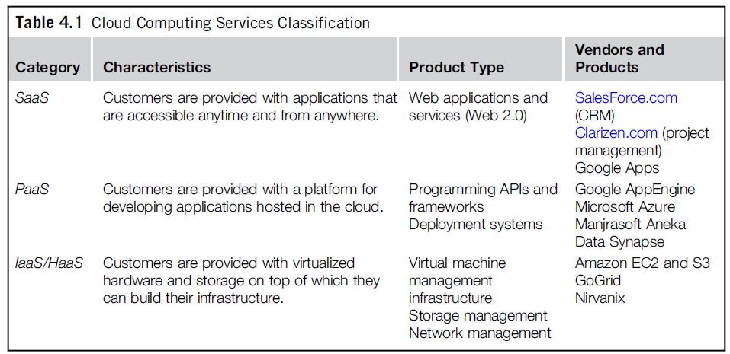
Infrastructure- and hardware-as-a-service
Infrastructure and Hardware-as-a-Service (IaaS/HaaS) solutions are the most popular and developed market segment of cloud computing.
They deliver customizable infrastructure on demand.
The available options within the IaaS offering umbrella range from single servers to entire infra- structures, including network devices, load balancers, and database and Web servers. The main technology used to deliver and implement these solutions is hardware virtualization: one or more virtual machines opportunely configured and interconnected define the distributed system on top of which applications are installed and deployed.
Virtual machines also constitute the atomic components that are deployed and priced according to the specific features of the virtual hardware: memory, number of processors, and disk storage.
IaaS/HaaS solutions bring all the benefits of hardware virtualization: workload partitioning, application isolation, sandboxing, and hard- ware tuning.
From the perspective of the service provider, IaaS/HaaS allows better exploiting the IT infrastructure and provides a more secure environment where executing third party applications.
From the perspective of the customer it reduces the administration and maintenance cost as well as the capital costs allocated to purchase hardware. At the same time, users can take advantage of the full customization offered by virtualization to deploy their infrastructure in the cloud; in most cases virtual machines come with only the selected operating system installed and the system can be configured with all the required packages and applications, other solutions provide prepackaged system images that already contain the software stack required for the most common uses, such as web servers, database servers, or LAMP stacks.
Besides the basic virtual machine management capabilities, additional services can be provided, generally including the following: SLA-based resource allocation, workload management, support for infrastructure design through advanced web interfaces, and the ability to integrate third-party IaaS solutions.
Below figure provides an overall view of the components forming an Infrastructure-as-a-Service solution. It is possible to distinguish three principal layers: the physical infrastructure, the software management infrastructure, and the user interface. At the top layer, the user interface provides access to the services exposed by the software management infrastructure. Such an interface is generally based on Web 2.0 technologies such as web services, RESTful APIs, and mash-ups. These technologies allow either applications or end users to access the services exposed by the underlying infrastructure. Web 2.0 applications allow the development of full-featured management consoles completely hosted in a browser or web page. Web services and RESTful APIs allow programs to interact with the service without human intervention, thus providing complete integration within a software system.
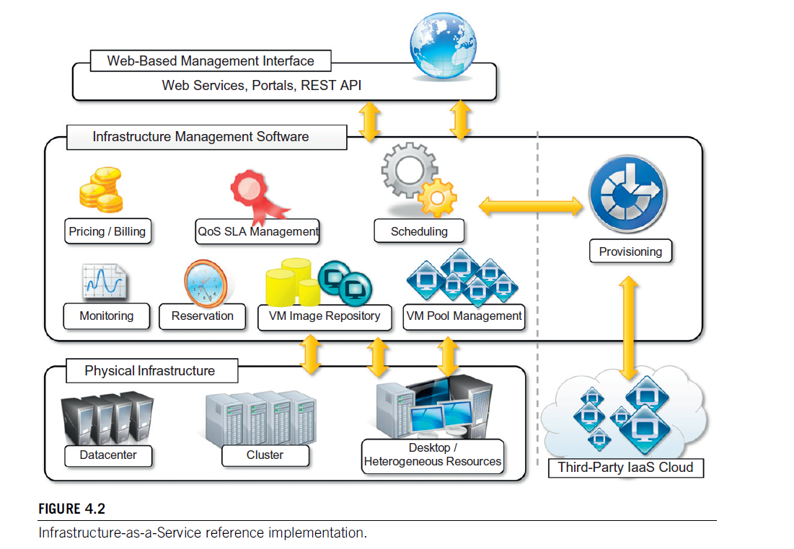
The core features of an IaaS solution are implemented in the infrastructure management software layer. In particular, management of virtual machines is the most important function performed by this layer. A central role is played by the scheduler, which is in charge of allocating the execution of virtual machine instances. The scheduler interacts with other components that perform a variety of tasks:
• The pricing and billing component takes care of the cost of executing each virtual machine instance and maintains data used to charge the user.
• The monitoring component tracks the execution of each virtual machine instance and maintains data required for reporting and analyzing system performance.
• The reservation component stores information about all virtual machine instances that have been executed or are scheduled to be executed in the future.
• If support for QoS-based execution is provided, a QoS/SLA management component maintains a repository of all SLAs made with users. Together with the monitoring component, it ensures that a given virtual machine instance is executed with the desired quality of service.
• The VM repository component provides a catalog of virtual machine images that users can use to create virtual instances. Some implementations also allow users to upload their own virtual machine images.
• A VM pool manager component is responsible for keeping track of all live instances.
• Finally, if the system supports integration of additional resources belonging to a third-party IaaS provider, a provisioning component interacts with the scheduler to provide a virtual machine instance external to the local physical infrastructure directly managed by the pool.
The bottom layer is composed of the physical infrastructure, on top of which the management layer operates. As previously discussed, the infrastructure can be of different types, depending on the specific use of the cloud. A service provider will most likely use a massive data center containing hundreds or thousands of nodes. A cloud infrastructure developed in-house, within a small or medium-sized enterprise or a university department, will most likely rely on a cluster. At the lower end of the scale, it is also possible to consider a heterogeneous environment where different types of resources—PCs, workstations, and clusters—are aggregated. This case mostly represents an evolution of desktop grids, where available computing resources (such as PCs and workstations idle outside working hours) are harnessed to provide significant computing power. From an architectural point of view, the physical layer also includes virtual resources rented from external IaaS providers.
In the case of complete IaaS solutions, all three levels are offered as a service. This is generally the case with public cloud vendors such as Amazon, GoGrid, Joyent, RightScale, Terremark, Rackspace, ElasticHosts, and Flexiscale, which own large data centers and provide access to their computing infrastructures using an IaaS approach. Other solutions instead cover only the user interface and the infrastructure software management layers. They need to provide credentials to access third-party IaaS providers or to own a private infrastructure in which the management software is installed. This is the case with Enomaly, Elastra, Eucalyptus, OpenNebula, and specific IaaS (M) solutions from VMware, IBM, and Microsoft. The proposed architecture only represents a reference model for IaaS implementations. It has been used to provide general insight into the most common features of this approach for providing cloud computing services and the operations commonly implemented at this level. Different solu- tions can feature additional services or even not provide support for some of the features discussed here. Finally, the reference architecture applies to IaaS implementations that provide computing resources, especially for the scheduling component. If storage is the main service provided, it is still possible to distinguish these three layers. The role of infrastructure management software is not to keep track and manage the execution of virtual machines but to provide access to large infrastruc- tures and implement storage virtualization solutions on top of the physical layer.

Platform as a service
Platform-as-a-Service (PaaS) solutions provide a development and deployment platform for running applications in the cloud. They constitute the middleware on top of which applications are built. A general overview of the features characterizing the PaaS approach is given in below figure
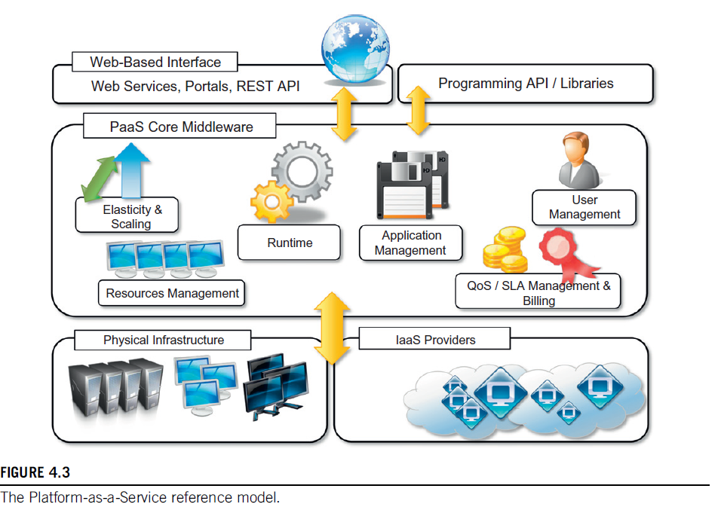
Application management is the core functionality of the middleware. PaaS implementations provide applications with a runtime environment and do not expose any service for managing the underlying infrastructure. They automate the process of deploying applications to the infrastructure, configuring application components, provisioning and configuring supporting technologies such as load balancers and databases, and managing system changes based on policies set by the user.
Developers design their systems in terms of applications and are not concerned with hardware (physical or virtual), operating systems, or other low-level services. The core middleware is in charge of managing resources and scaling applications on demand or automatically, according to the commitments made with users. From a user point of view, the core middleware exposes interfaces that allow programming and deploying applications in the cloud. These interfaces can be in the form of a web-based interface or programming APIs and libraries.
The specific development model adopted for applications determines the interface exposed to the user. Some implementations provide a completely web-based interface hosted in the cloud and offering a variety of services. It is possible to find integrated development environments based on 4GL and visual programming concepts, or rapid prototyping environments where applications are built by assembling mash-ups and user-defined components and are subsequently customized. Other implementations of the PaaS model provide a complete object model for representing an application and adopt a programming language–based approach. This approach generally offers more flexibility and opportunities but incurs longer development cycles. Developers typically have access to the full power of programming languages such as Java, .NET, Python, or Ruby, with some restrictions to ensure better scalability and security. In this case, traditional development environments can be used to design and develop applications, which are then deployed to the cloud using the APIs exposed by the PaaS provider. Specific components may be offered together with the development libraries to better exploit the services provided by the PaaS environment. Sometimes, a local runtime environment that simulates cloud conditions is provided for testing applications before deployment. This environment may be restricted in terms of features and is generally not optimized for scaling.
PaaS solutions can offer middleware for developing applications together with the infrastructure, or simply provide users with the software that is installed on user premises. In the first case, the PaaS provider also owns large data centers where applications are executed. In the second case, referred to in this book as Pure PaaS, the middleware constitutes the core value of the offering. It is also possible to have vendors that deliver both middleware and infrastructure while shipping only the middleware for private installations.
The PaaS umbrella encompasses a variety of solutions for developing and hosting applications in the cloud. Despite this heterogeneity, it is possible to identify some criteria that are expected to be found in any implementation. As noted by Sam Charrington, product manager at Appistry.com,2 there are some essential characteristics that identify a PaaS solution:
• Runtime framework. This framework represents the “software stack” of the PaaS model and is the most intuitive aspect that comes to people’s minds when they refer to PaaS solutions. The runtime framework executes end-user code according to the policies set by the user and the provider.
• Abstraction. PaaS solutions are distinguished by the higher level of abstraction they provide. Whereas in IaaS solutions the focus is on delivering “raw” access to virtual or physical infrastructure, in PaaS the focus is on the applications the cloud must support. This means that PaaS solutions offer a way to deploy and manage applications in the cloud rather than a set of virtual machines on top of which the IT infrastructure is built and configured.
• Automation. PaaS environments automate the process of deploying applications to the infrastructure and scaling them by provisioning additional resources when needed. This process is performed automatically and according to the SLAs made between the customers and the provider. This feature is normally not native to IaaS solutions, which only provide ways to provision more resources.
• Cloud services. PaaS offerings provide developers and architects with services and APIs that help simplify the creation and delivery of elastic and highly available cloud applications. These services are key differentiators among competing PaaS solutions and generally include specific components for application development, as well as advanced services for application monitoring, management, and reporting.
Another essential component of a PaaS-based approach is the ability to integrate third-party cloud services offered by other vendors by leveraging service-oriented architecture. Such integration should occur through standard interfaces and protocols. This capability makes application development more agile and enables applications to evolve according to the needs of customers and users. Many PaaS offerings provide this facility, which is naturally built into the frameworks they leverage to deliver cloud computing solutions.
One of the major concerns when leveraging PaaS solutions for implementing applications is vendor lock-in. Unlike IaaS solutions, which deliver bare virtual servers that can be fully customized in terms of the installed software stack, PaaS environments deliver a platform for developing applications that exposes a well-defined set of APIs and, in most cases, binds the application to the specific runtime of the PaaS provider. Although a platform-based approach strongly simplifies the development and deployment cycle of applications, it poses the risk of making these applications completely dependent on the provider. Such dependency can become a significant obstacle when retargeting the application to another environment or runtime if the commitments made with the provider cease.
The impact of vendor lock-in on applications varies across different solutions. Some, such as Force.com, rely on proprietary runtime frameworks, which make the retargeting process very difficult. Others, such as Google App Engine and Microsoft Azure, rely on industry-standard runtimes but utilize private data storage facilities and computing infrastructure. In this case, it is possible to find alternatives based on PaaS solutions that implement the same interfaces, possibly with different performance characteristics. Others, such as Appistry Cloud IQ Platform, Heroku, and Engine Yard, rely completely on open standards, thus making the migration of applications easier.
Finally, from a financial standpoint, although IaaS solutions allow shifting capital costs into operational costs through outsourcing, PaaS solutions can reduce costs across the development, deployment, and management of applications. They help management reduce the risk posed by rapidly changing technologies by offloading the cost of technology upgrades to the PaaS provider. This process occurs transparently for consumers of this model, allowing them to concentrate their efforts on the core value of their business.
The PaaS approach, when bundled with underlying IaaS solutions, helps even small startup companies quickly offer customers integrated solutions on a hosted platform at a very minimal cost. These opportunities make PaaS a viable option that targets different market segments.

